Walk-around checklist

Date of energy walk-around: _____________
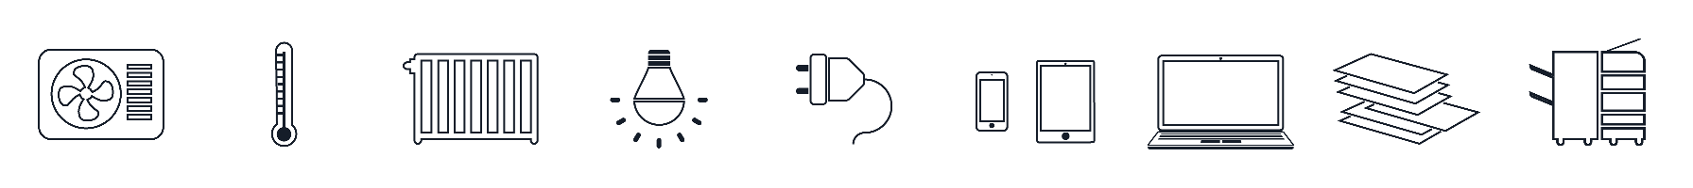
Walk-around completed by: ______________

Heating / cooling | Checked ✓ | Further action needed?
Are there staff complaints about the temperature?
Have heaters/boilers/air conditioners been serviced in the last 12 months?
Are portable heaters/fans being used?
Are heaters and air conditioning units operating in the same space?
If hot water is provided, is it being wasted (such as dripping taps, or leaking urns)?
Do all areas have the same heating/cooling requirements?
Is the room thermostat working and set to the correct temperature?
Are the heating/cooling timers working and on the correct settings?
Are other heating/cooling controls working and on the correct settings?
Are there obstructions in front of radiators, heaters or air conditioning units?
How are extractor fans controlled (e.g. in toilets)?
Are windows and doors open when heating or air conditioning is on?
Are there any cold draughts coming from windows or doors?
Lighting | Checked  ✓ | Further action needed?
Are lights switched off (if daylight sufficient/room not in use)?
Are any old, large diameter (1.5 inches) fluorescent tubes still in use?
Are lamps, fittings and rooflights clean?
Are traditional tungsten light bulbs still in use?
Are light switches arranged conveniently and labelled?
Is exterior lighting switched off when not needed?
Office equipment | Checked ✓ | Further action needed?
Have computers got built-in energy saving features — and are they activated?
Are computers left on overnight?
Are monitors and fans switched off when not in use?
Are photocopiers located in air conditioned areas?
Are printers and photocopiers left on overnight/at weekends?
Are vending machines/water coolers left on all the time?

